**BMS18 – Heterogeneity – subgroup analysis and meta-regression**

**Self study assignment**

**Estimated time: 2 hours**

**Topics:**

1. Simple meta-analysis: topical steroids example
   * Discussion Hartung-Knapp (HKSJ) vs. Normal distribution for confidence intervals
   * Prediction intervals vs. Confidence intervals
   * Sensitivity analysis
2. Meta-regression for RR outcome.
3. Preparation for next week.

**For this assignment you need R and RStudio.**  
You can download this for free at your private laptop, or use the Radboudumc computer rooms.

An installer for R (for various platforms) can be downloaded from

<http://cran.us.r-project.org/>

An installer for RStudio (desktop) can be downloaded from

<https://www.rstudio.com/products/rstudio/download3/#download>

# Topical steroids for treatment of chronic rhinosinusitis with nasal polyps

A 2012 Cochrane review on the use of topical steroids for treatment of chronic rhinosinusitis with nasal polyps, based on seven randomised studies, resulted in a larger decrease in overall symptom scores in favour of steroids compared with placebo.

This is reflected by a standardised mean difference (SMD) of −0.51.   
The I2 is 73.9% (95% CI 44.2% to 87.8%), which can be considered substantial heterogeneity according to the Cochrane Handbook, and the estimated τ2 is 0.148.

Notwithstanding these numbers, it is difficult to evaluate what the clinical consequences of this heterogeneity may be for future settings.

[Kalish L, Snidvongs K, Sivasubramaniam R, et al. Topical steroids for nasal polyps. Cochrane Database Syst Rev 2012;12: CD006549.]

We will investigate this example step by step, starting with a short refresher of the theory of last week.

Data to be used are in *topical_steroids.xlsx*. We will use the package meta.

1. Consider a small study, taken from a meta-analysis with quite some between-study heterogeneity. Is this study relatively more important (for the pooled result) in a fixed-effect or in a random-effects meta-analysis? Explain your answer.

The weights of small studies are higher in random effects models. The reason is that along with their initial weight calculated by their inverse variance we also add the τ2 estimate to all weights. Therefore, the contribution of the studies is shrunk towards the τ2. Consequently, the large studies contribute less to the pooled estimate, while the small studies more.

1. Conduct a fixed and a random-effects meta-analysis, using the PM estimator for the tau2.   
   The effect size measure (sm=) is the SMD.

Res= metacont(total.Steroid, mean.Steroid, sd.Steroid,

total.PL, mean.PL, sd.PL,

data=topical_steroids,

prediction =TRUE,

sm="SMD", studlab=study, method.tau="EB")

Res # to see the results

Compare the width of the 95% CI for the fixed effect and the random-effects meta-analyses.

The 95% Cis of the fixed effects model is [-0.6539; -0.2713], while those of the random effects model is [-0.8700; -0.1563].

Which one is wider?

The random-effects model CIs are wider.

Why?

The random-effects model is taking into account the between-study heterogeneity. Under the fixed-effect model the only source of uncertainty is the within-study standard error, while under the random-effects model an additional source (between-studies heterogeneity) is added to the previous source of uncertainty. Therefore, we are less “confident” over our pooled estimate, and as a consequence we the intervals were the true treatment effect lies with a probability of 95% are wider.

Also check the weights. What happened to the weights if you compare the fixed and the random effects weights?

The weights of the “more” precise (larger) studies of Johansson, Jorissen and Vickona are lower in the random-effects model than in the fixed-effect model, while the smaller studies weights are increased.

1. By default, most meta-analysis programs assume that the number of studies in the meta-analysis is large. In that situation, the 95% CI can be calculated using the normal (z-) distribution, i.e. as   
    *pooled estimate ± 1.96 x SE*  
   Also in meta this is the default approach, so the 95% CI that is calculated by meta (and also by RevMan) is based on this z-distribution. This is based on the assumption that we have a precise estimate of the standard error for the calculation of the confidence interval.  
     
   Report the pooled estimate and the 95% CI for the SMD between the steroids and placebo, using the random-effects meta-analysis.

The SMDpooled = -0.51 in the random effects model, with a CI of [-0.87, -0.16].

1. Often the number of studies in a meta-analysis is small, like in our example, where we have only 7 studies. In that situation the SE that is needed to calculate the confidence interval cannot be estimated very precise. The use of the factor 1.96 to calculate the 95% CI will result in confidence intervals that are too optimistic, i.e. too narrow.   
     
   A better approach is to use the Hartung-Knapp ( or: HKSJ) method to calculate the confidence intervals. This method is based on the t-distribution, with as degrees of freedom the number of studies – 1, instead of the normal distribution. If the number of studies is large (>30) the t-value will be around 2, and very similar to the z-value 1.96, but for a lower number of studies, the t-value will be larger than 2, which results in a wider 95% CI.   
   (Note that the HKSJ method is a bit more complex than we state here).

Report the pooled estimate and the 95% CI for the SMD , based on the Hartung-Knapp approach (hakn=TRUE). Compare the width of this confidence interval with the previous result.

The random effects pooled estimate with the Hartung-Knapp approach didn’t change (SMDpooled = -0.51), while the Cis became wider [-0.9587; -0.0676].

Do you know which t-value has been used?

Look at the following t Table.

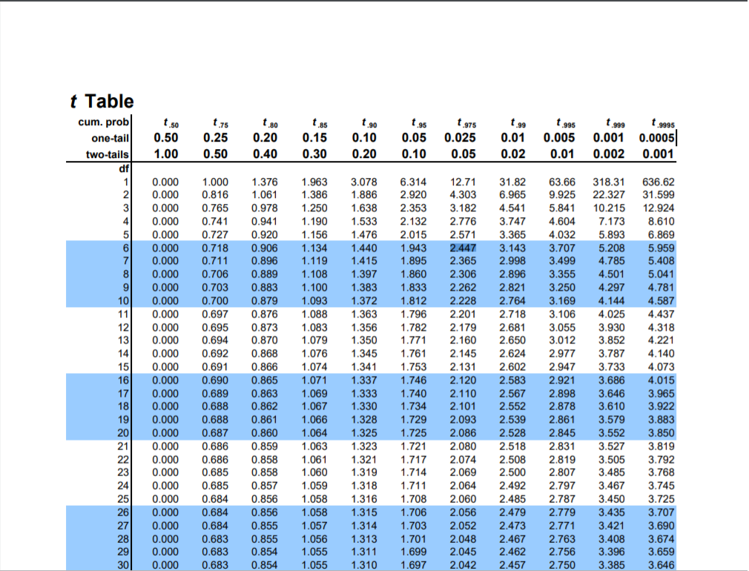

Since we have 7 studies the degrees of freedom are 7-1= 6. Therefore, we will use the t-value of 2.447 for a 0.05 two-tailed significance level. Therefore, the CIs will be calculated with the SMDpooled

1. Make a forest plot for the meta-analysis that you conducted in the previous step.

Forest(Res)

1. If you look at the forest plot. Which treatment effect can we expect if we would apply the topical steroid in our own hospital?



1. Most software for meta-analysis will not generate by default a prediction interval, although it is one of the most essential outcomes in a random-effects model, i.e. when it must be assumed that ‘true’ effect sizes vary, and it is much easier to understand than the other measures for heterogeneity like tau2.

**What is the difference between the confidence and prediction intervals of the combined effect size?**

A 95% prediction interval gives the range in which, in 95% of the cases, the outcome of a future single study will fall, assuming that the effect sizes are normally distributed (of both the included, and not (yet) included studies).

This in contrast to the 95% confidence interval, which is interpreted as indicating a range within which we can be 95% certain that the true combined effect lies.

1. The weights represent the influence of the individual studies on the combined effect. However, some studies are further away from the pooled effect estimate than others. We can also conduct a sensitivity analysis, by investigating what happens to the pooled effect if each time, one study is removed from the meta-analysis.   
     
   Do this with the metainf command in the package meta, based on the meta-analysis result that you created before, e.g.:  
     
   metainf(result.meta, pooled = "random")

You will see the results of the meta-analysis of 6 studies, i.e. omitting one study, and the result for the pooled estimate as before, based on the 7 studies.   
  
Which (omitted) study has a large effect on the pooled estimate? What is the effect of omitting this study / these studies (one by one)? If you would be conducting this meta-analysis, this could be a reason to have a more in depth look again at the article of this author.

Influential analysis (Random effects model)

SMD 95%-CI p-value tau^2 I^2

**Omitting Filiaci 2000 -0.4096 [-0.8863; 0.0671] 0.0782 0.1210 70.4%**

Omitting Holopainen 1982 -0.5257 [-1.0592; 0.0079] 0.0524 0.1873 78.2%

Omitting Johansson 2002 -0.5383 [-1.0942; 0.0176] 0.0552 0.1854 78.2%

**Omitting Jorissen 2009 -0.6807 [-0.9519; -0.4094] 0.0013 0.0000 0.0%**

Omitting Mastalerz 1997 -0.5098 [-1.0518; 0.0322] 0.0603 0.1878 78.2%

Omitting Mygind 1975 -0.4655 [-0.9861; 0.0550] 0.0699 0.1667 76.8%

Omitting Vlckova 2009 -0.4701 [-1.0165; 0.0763] 0.0779 0.1759 75.7%

Pooled estimate -0.5131 [-0.9587; -0.0676] 0.0304 0.1477 73.9%

# Blood pressure lowering treatment for prevention of cardiovascular disease

**Background   
The benefits of blood pressure lowering treatment for prevention of cardiovascular disease are well established. However, the extent to which these effects differ by drug class or other factors is less clear. Ettehad et al. (Lancet, 2016) performed a systematic review and meta-analysis to clarify these differences.**

**Medline was searched for large-scale blood pressure lowering trials. Randomised controlled trials of blood pressure lowering treatment were eligible for inclusion if they included a minimum of 1000 patient-years of follow-up in each study arm.**

**In total, the authors included 123 studies with 613,815 participants.**

1. **To evaluate the relation between reduction in major cardiovascular disease events in relation to the achieved blood pressure reduction, the authors performed meta-regression.   
   This resulted in an estimated risk ratio (RR) of 0.80 per 10 mmHg of reduction.**

**How large is the reduction in the risk for major cardiovascular disease events per 10 mmHg blood pressure reduction?**

1. **Assume a cardiovascular disease event rate of 10% in the control group.   
   Explain which event rate you expect in the experimental group if the difference in Systolic Blood Pressure (SBP) between the control and experimental group is 10 mmHg?**
2. **And what event rate do you expect in the experimental group if the difference is 15 mmHg?**

**Figure 2.1 (below) shows the fixed-effect meta-regression results for all-cause mortality in relation to systolic blood pressure reduction. Studies are indicated with small and large circles (bubbles).**

1. **Try to give a formula for the regression line.**

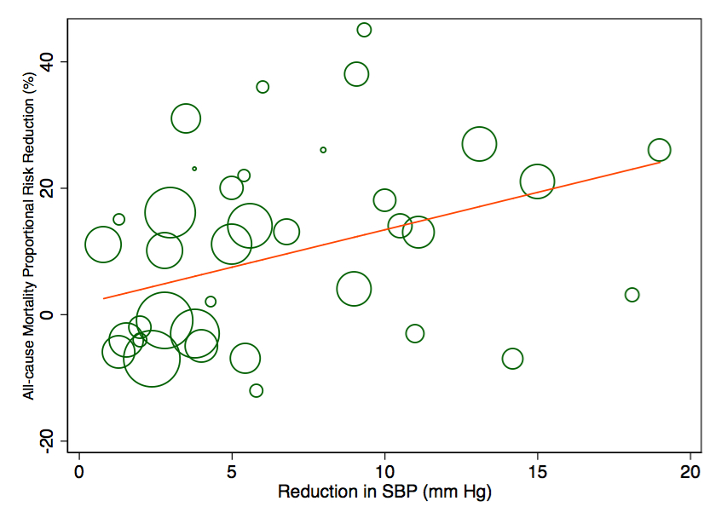

*Figure 2.1****.***  *Meta-regression plot of the percentage risk reduction in all-cause mortality (y‑axis) regressed against the difference in achieved systolic blood pressure (SBP) between treatment arms (x-axis).*

# Preparation for next week:

Next week we will discuss publication bias.

Prepare by viewing the following TED talk from 2011, by Ben Goldacre (14:19 minutes), known for his criticism of bad science and bad pharma.

[https://www.ted.com/talks/ben_goldacre_battling_bad_science?language=en#t-274330](https://www.ted.com/talks/ben_goldacre_battling_bad_science?language=en)

